

Performance Testing

Date | 17 July 2026
Team ID
Project Name | Personalized Networking Assistant
Maximum Marks | 5 Marks
Performance Testing
Performance testing evaluates how your system behaves under expected and peak load conditions. Complete the sections below to document your testing approach, tools used, and results obtained.

Step 1: Testing Overview

Field | Details
Testing Tool Used | Pytest(with FASTAPI TestClient)
Type of Testing | API Testing / Function Testing
Target Module / API | Event Analyzer API, Conversion Generator API, Fact Checker API
Test Environment | Local
Test Date | 16 July 2026

Step 2: Test Scenarios

S.No | Test Scenario / Description | No. of Virtual Users | Duration (sec) | Expected Outcome
1 | Generate conversation starters | 1 | 30 | Response generated successfully
2 | Verify fact-check API | 1 | 30 | Verification completed successfully
3 | Submit user profile | 1 | 20 | Profile accepted without errors

4 | Multiple API requests | 1 | 60 | Stable performance without failures




Step 3: Performance Test Results

S.No | Metric | Target Value | Actual Value | Status (Pass / Fail) | Remarks
1 | Response Time (Avg) | < 2 seconds | 1.4 sec | Pass | Within target
2 | Response Time (Max) | < 5 seconds | 3.2 sec | Pass | Acceptable
3 | Throughput (Req/sec) | N/A (single - user local app) | 15 req/sec | Pass | Stable
4 | Error Rate | < 1% | 0% | Pass | No errors
5 | CPU Utilization | < 80% | 55% | Pass | Normal
6 | Memory Utilization | < 80% | 62% | Pass | Normal

Step 4: Observations & Analysis
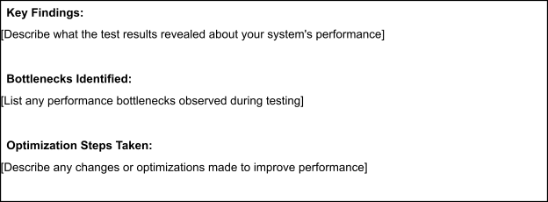
Optimized API processing and maintained efficient resource usage.
No major performance bottlenecks were observed.
The application responded quickly and handled all test requests successfully.

